**U.S. Department of Energy (DOE)  
Clean Energy to Communities (C2C) Program**

Summary of Technical Assistance (TA) Support

|  |
| --- |
| Marker with solid fill |
| Icon  Description automatically generatedBuildings |
| Icon  Description automatically generatedClean Power |
| Climate Mitigation and Resilience |
| Cross-Sectoral Justice |
| A picture containing text, clipart  Description automatically generatedJobs and Economic Development |
| Icon  Description automatically generatedMobility |

**Pinellas, Florida**

TA Scope

From June through October 2023, the National Renewable Energy Laboratory (NREL) provided technical support the Institute for Equitable Development (I4ED), Inc., to inform clean energy workforce development programs. Specifically, the expert team completed the following:

* NREL provided technical input on workforce development best practices focused on solar photovoltaics (PV) and electric vehicle (EV) careers.
* The expert team authored documents that outlined on best practices for developing robust solar career pathways and robust sustainable transportation career pathways, with a focus on careers in the clean mobility industry, including EVs.
* The research in these documents centered best practices specific to underserved populations such as communities of color, women, and non-college-educated populations.
* NREL and the I4ED team cocreated technical input to draft a framework for a potential capacity building workforce event in Pinellas County.
* The expert team developed a framework for a pilot capacity-building event in collaboration with the I4ED team and input from other community partners. Incorporating the findings of the best practice memos in Work Area 1, the draft framework created a model that can be replicated in similar communities with similar goals.

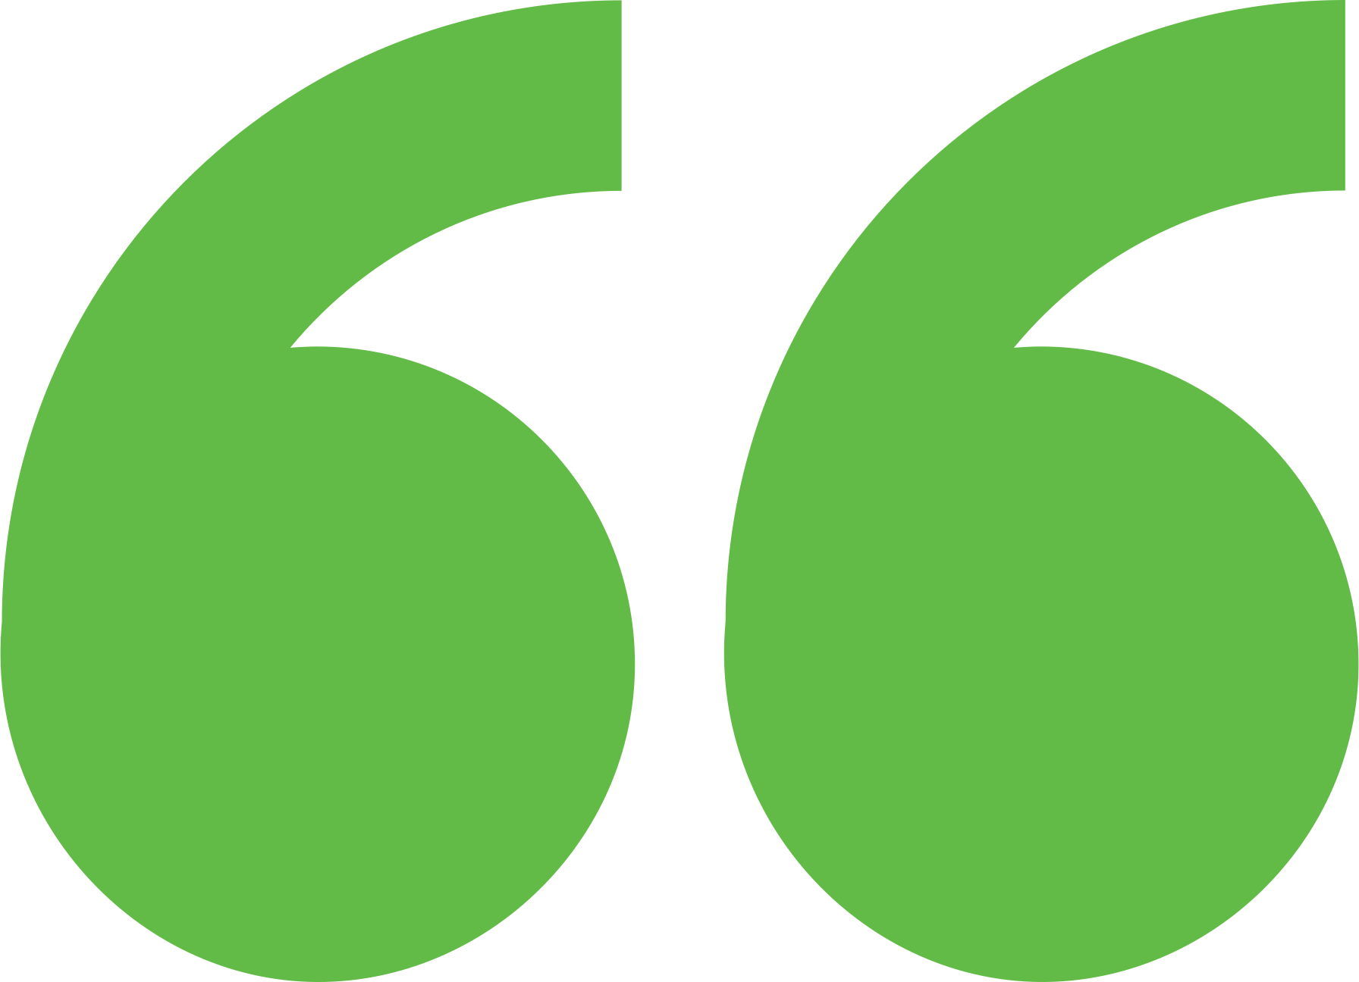 Impact

NREL realized during this process that they didn’t have the tools to understand “workforce demand” around solar and EV jobs, which was the primary ask of this request. Additionally, because of Florida’s complex regulatory framework around solar, the community was shocked to learn that there was actually not as much opportunity in the state as they had expected. They decided to “go back to the drawing board” around their plans for workforce development while they learn more about their local workforce needs and opportunities. This team may be a pilot community for NREL’s upcoming WIRED tool, which can better meet the needs of their request.

Background

**Background**

Ann Arbor is a city of approximately 122,000 people located in southeast Michigan. The city and its residents are leaders in sustainability and climate action. Their A2ZERO Climate Action Plan outlines their just transition pathway to community-wide carbon neutrality by 2030. With equity as a focus, they are implementing strategies to improve home energy efficiency (EE) and electrify appliances. Toward this, the city wants to explore community geothermal heating and cooling to serve a variety of building types including rental and affordable housing. The city has applied to DOE’s Geothermal Heating and Cooling Design and Deployment program and garnered the support of City Council to pursue these projects, but they need to understand the concept’s feasibility in order to make a “go, no-go” decision.

I4ED has a mission to promote fair treatment and meaningful involvement of all people regardless of race, color, national origin, or income with respect to economic and social development. I4ED has identified a need to educate, train, and provide entrepreneurship opportunities in clean energy resilience jobs for low-income residents in Pinellas County, Florida. The organization applied to C2C because of their interest in exploring best practices and lessons learned for workforce development, career pathways in the clean energy sector, implementing clean energy (particularly concentrating on the solar PV sector), and entrepreneurship programs, tailored for the renewable energy sector. The organization’s work is focused on codeveloping workforce development solutions that primarily support underserved communities in Pinellas County often facing socioeconomic challenges that limit access to high-growth industries.

Expert Match Team

**Alexandra Kramer**  
Community Lead, Main Expert Match Point of Contact, NREL

**Sika Gadzanku**  
C2C Expert Match Program Manager, NREL

**Dana-Marie Thomas**  
Researcher, Equitable Energy Adoption Expert, NREL

Community Team

**Saundra Johnson Austin**  
President, I4ED

**Velma Deleveaux**  
Project Co-Lead

For more information, visit:  
**energy.gov/eere/clean-energy-communities-program**

August 2024